Southwest Pennsylvania Area Health Education Center (AHEC), Inc. is pleased to announce its 17th annual AHEC Summer Health Career Academy for academically inclined ninth and tenth grade students from seven southwestern Pennsylvania counties. These are Allegheny, Armstrong, Beaver, Fayette, Greene, Washington, and Westmoreland. The cost for the program is $200, which includes tuition, course materials, field trips, and lunch during the academy. Scholarships are available for those who demonstrate the need.

The Health Career Academy will take place for five days, July 15-19, 2019 on the main campus of the University of Pittsburgh. The academy is designed for current ninth and tenth grade students who are interested in learning about opportunities in various health careers and the academic preparation necessary for these careers.

Students will meet and talk to practicing health care professionals, engage in health career activities, learn to monitor vital signs, engage in hands on medical procedures, learn basic medical terminology, and receive training in leadership skills.

Transportation may be arranged on an as needed basis to Pitt’s Oakland campus daily.

Lunch will be provided for students each day.

The Health Career Academy includes information on:

- Health career opportunities
- Health career pathways
- Public health issues
- Health career shortages and shortage areas
- Medical terminology
- Health related cultural competency
- Leadership skills
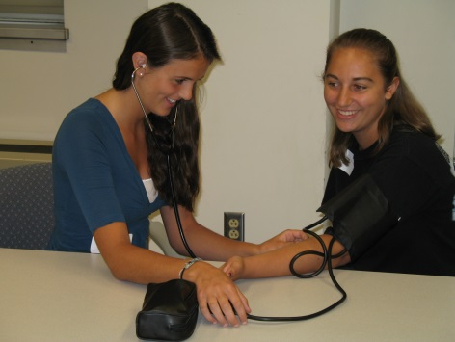

Students will:

- Meet and interact with practicing health professionals
- Research a specific health profession
- Visit the Pitt Medical School
and learn defibrillation, choking prevention, and intubation techniques
- Visit the Pitt Dental School and
Clinic
- Visit the WISER Center to view medical simulation

The program is coordinated and supported by the Southwest Pennsylvania Area Health Education Center (AHEC) in partnership with the University of Pittsburgh School of Medicine.

Students will be selected by Summer Health Career Academy Advisory Board members through a competitive selection process. Board members will use the information provided by student applications and letters from their school teachers, guidance counselors, or school administrators. These letters must indicate that the student is academically inclined in subject areas. A parent or guardian must indicate acknowledgement of the student’s application by providing a signature on the application. The Advisory Board, representing academic and health care professionals from counties in the AHEC region, will make the final student selections.

All students will receive written notification of their admission decision, those accepted into the program will also receive acceptance letters and preparatory information about the program. Students are required to prepare a presentation for the student recognition program at the end of the week. Parents will also be invited to attend the afternoon presentation on
the last day.

To Apply:

- Complete the application.

- Include a letter of recommendation from a teacher, guidance counselor, or school administrator.

- Include a one-page letter of interest, written by the student, expressing interest in the program.

Applications and this brochure may be duplicated for distribution purposes.

Scholarships available upon request.

All applications must be received by Friday, April 26, 2019.

Mail to:

Kristy Wiles
Program Coordinator
Southwest Pennsylvania AHEC, Inc.
6 Loop St. Suite 3
Pittsburgh, PA 15215

For additional information, please call:
412-408-3485 or log on to:

http://www.southwestahec.org
(click on Summer Health Career Academy Information)

Daily Academy Schedule

8:30 a.m. Arrive at Pitt campus
8:45 a.m. Morning Academy briefing
9:00 a.m. Program begins
11:30 a.m. Lunch and lunch time
speakers
12:30 p.m. Program begins
3:00 p.m. Dismissal

What some students have said about the academy:

“I really enjoyed this week and the academy. It was such as amazing experience and I know so much more about health careers.”

“I am astonished every time I board the bus because I can’t believe everything I’ve accomplished in one day.”

“This week was a good experience that helped me broaden my knowledge of the medical world. I am now very interested in becoming a physician assistant and would not know about it if it were not for the AHEC Summer Academy.”

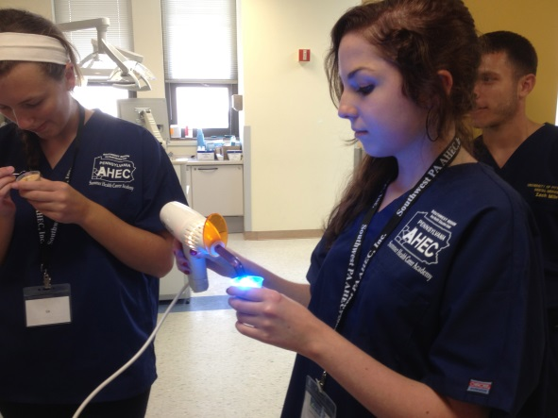

Funding for previous academies has been provided by a grant from the Pennsylvania Department of Education.

Funding for the Pennsylvania Area Health Education Center Program is provided by the Department of Health and Human Services, Health Resources and Services Administration and the Pennsylvania Department of Health. The Commonwealth’s medical community and communities at large provide additional support.

The 17th Annual
Southwest Pennsylvania
Area Health Education Center
(AHEC)

Summer

Health Career Academy

A Southwestern Pennsylvania Summer School of Excellence
for
Academically Inclined
Ninth and Tenth Grade Students

July 15-19, 2019

University of Pittsburgh
School of Medicine

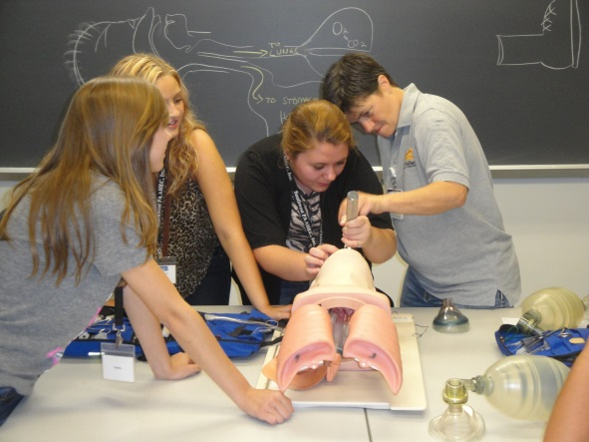

…a unique opportunity

for high school students

interested in health careers.

