AP Biology Summer Assignment 2022
Text: Biology in Focus, Third Edition. Campbell, Urry, Cain, Wasserman, Minorsky 2020
Happy summer and welcome to AP Biology! I am looking forward to meeting you all, and am excited to journey through AP Bio with each of you!
AP Biology is a fast-paced course that covers a lot of content. The units are as follows:
Unit 1: The Chemistry of Life
Unit 2: Cell Structure and Function
Unit 3: Cell Energetics
Unit 4: Cell Communication and Cell Cycle Unit 5: Heredity and Genetics
Unit 6: Gene Expression and Regulation
Unit7: Natural Selection and Evolution
Unit 8: Ecology

The content as designated for the AP Biology curriculum by the college board is a lot to get through in the course of one academic school year. To ensure that we have enough time to cover all content, and have time to review, by the AP test, your summer assignment will cover units 1 using Khan Academy. Khan Academy is a online platform that offers great content for many subjects. The first thing you will need to do is create an account on the website. The account is free, and gives you access to tons of review material for many subjects. Once you create your account, you will need to join our class. To do this:
- Click on your name in the top right corner, and select the tab “Learner Home.
- In the tool bar on the left, select “teachers:
- It will take you to a page titled “My teachers and tutors”. Click on the tab that says “Enter a class code”, underneath Join a class.
- Enter the following code:
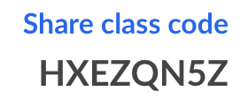
- Select to join the class “AP Biology 1”.
- When you return to your “Learner Home” page, you will be able to see the assignments posted for Unit 1.

The following packet is to be used to fill out the notes as you watch the videos and read the articles. The site takes note of which articles you read and videos you watch. You are required to do all of these in the Unit 1 assignment. Additionally, you must do all of the practice activities, quiz 2 (only 5 questions), and the unit test (only 9 questions). This assignment will be due at midnight on August 29th.
The scoring for the summer work is as follows:
2 points for each task (video/reading): 37 total task: 74 points
3 points for each exercise: 5 total exercises: 15 points
5 points for each quiz: 2 quizzes: 10 points
20 points for unit test
Total points for summer assignment: 120 points
(yes I know the points only add up to 119 but that annoyed me so I will give everyone a free point to make it 120:)
If you have any questions, feel free to email me! I am so excited to start this school year with you all!!!!

Ms. Grob
agrob@oaklandcatholic.org

Chemistry of Life

Hydrogen Bonds in Water

Water owes its unique properties to the _______________ of its molecules and, specifically, to their ability to form hydrogen bonds with ____________ __________ and ___________ _____________.

A water molecule consists of two ___________ __________ bonded to an __________________ _____________ and its overall structure is _________________.

Because oxygen is more _________________ -electron greed-, than hydrogen, the O atom ________ electrons and keeps them away from H atoms. This gives the oxygen end of water a _________________ ______________ _____________, while the hydrogen end has a _________________ ______________ _____________.

Water is classified as a polar molecule because….
___________________________________________________________________________________________________________________________________________________________.

Thanks to their ____________, water molecules happily attract each other.

These attractions are an example of ________________, weak interactions that form between a _______________ with a partial positive charge and a more ___________________ atom, such as oxygen.

Label the image below with the following: partial negative charged, partial positive charges, covalent bond, hydrogen bond.

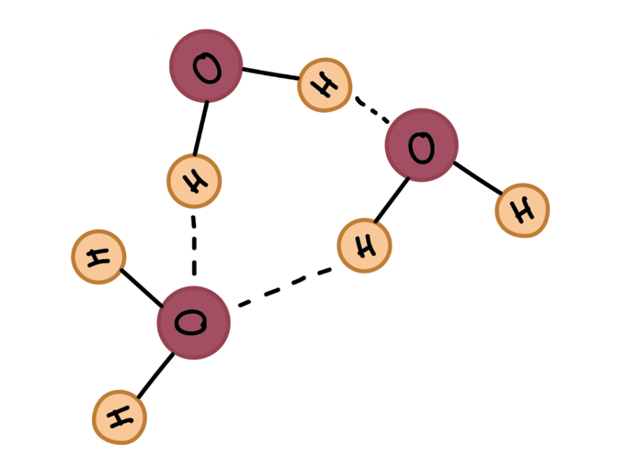

A charged or polar substance that interacts with and dissolves in water is said to be ____________________: hydro means "___________," and philic means "___________."

In contrast, nonpolar molecules like _______ and _______ do not interact well with water. They separate from it rather than dissolve in it and are called __________________: phobic means "____________."

Cohesion and adhesion of water

Explain the following properties of water, and give an example of them occurring in nature (ex: cohesion causes the dome-like shape above the rim of a glass).

Cohesion:

Surface Tension:

Adhesion:

Capillary action (include a drawing of a meniscus):

Density of ice and water (aka why does ice float instead of sink):

High specific heat capacity:

High heat of vaporization:

Evaporative cooling:

Matter, elements and atoms

The term ____________ refers to anything that occupies _________ and has __________—in other words, the “stuff” that the universe is made of. All matter is made up of substances called _______________, which have specific _____________ and _____________ properties and cannot be broken down into other substances through ordinary chemical reactions.

An atom consists of two regions. The first is the tiny ____________________, which is in the center of the atom and contains positively charged particles called _______________ and neutral, uncharged, particles called _______________. The second, much larger, region of the atom is a “cloud” of _________________, negatively charged particles that orbit around the nucleus. The attraction between the ____________ ____________ ___________ and ________________ ____________ ____________ holds the atom together. Most atoms contain all three of these types of ___________ _____________—protons, electrons, and neutrons.

Carbon and hydrocarbons

Carbon atoms make up the backbone of many important molecules in your body, including ________________, ______, ______, _______, and _______.

These complex biological molecules are often called ________________________; they’re also classified as ________________ _______________, which simply means that they contain _________ atoms.

The bonding properties of carbon

Why is carbon so popular for making molecular backbones?

____________________________________________________________________________________________________________________________________________________________

Carbon’s ability to form bonds with four other atoms goes back to its ____________ and ____________________ of __________. Carbon has an atomic number of ____ (meaning six protons, and six electrons as well in a neutral atom), so the first two electrons fill the______ _____ and the remaining four are left in the _________ _______, which is the _____________(outermost) shell. To achieve stability, carbon must find ___________ more electrons to fill its outer shell, giving a total of eight and satisfying the ______________ rule. Carbon atoms may thus form bonds to as many as _______ other atoms.

________________________ are organic molecules consisting entirely of carbon and hydrogen.

Functional Groups

_________________ are chemical motifs, or patterns of atoms, that display consistent “____________” (properties and reactivity) regardless of the exact molecule they are found in.

Fill in the following chart of the functional groups.
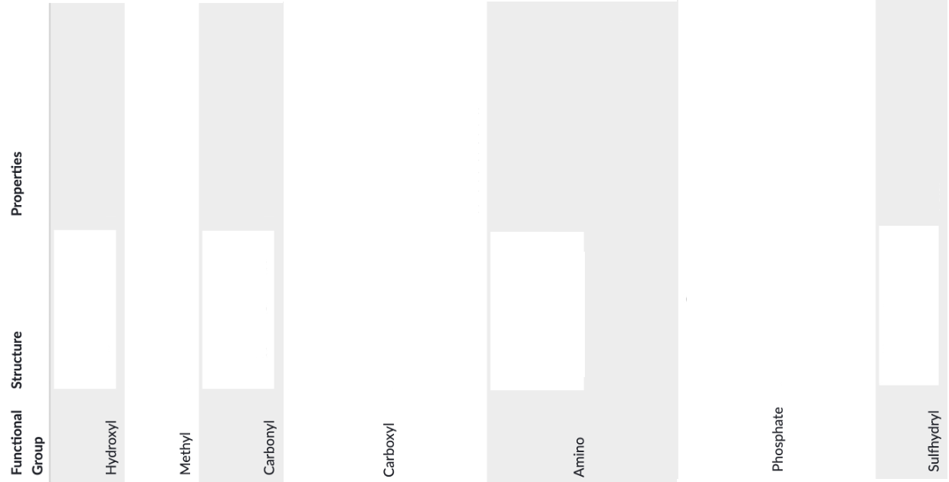
Introduction to Biomacromolecules

Some atoms become more stable by ___________ or __________ an entire electron (or several electrons). When they do so, atoms form _________, or charged particles.

_____________ are positive ions formed by losing electrons.
Example:

Negative ions are formed by electron gain and are called ___________.
Example:

When one atom loses an electron and another atom gains that electron, the process is called _________________.

____________ ___________ are bonds formed between ions with opposite charges.

Another way atoms can become more stable is by _______________ electrons (rather than fully gaining or losing them), thus forming ______________ ________.

Draw a picture of atoms showing an ionic bond, and a picture of atoms showing a covalent bond.

There are two basic types of covalent bonds: polar and nonpolar. In a _________ ___________ ________, the electrons are ____________ shared by the atoms and spend more time close to one atom than the other. Because of the unequal distribution of electrons between the atoms of different elements, slightly _____________ (___) and slightly _________ (___) charges develop in different parts of the molecule.

___________ covalent bonds form between two atoms of the same element, or between atoms of different elements that share electrons more or less __________.

Introduction to macromolecules

Most large biological molecules are _________________, long chains made up of repeating molecular subunits, or building blocks, called _______________.

Carbohydrates, nucleic acids, and proteins are often found as _________ polymers in nature. Because of their polymeric nature and their large (sometimes huge!) size, they are classified as _______________, big (macro-) molecules made through the joining of smaller subunits.

Large biological molecules often assemble via _____________ _________________ reactions, in which one monomer forms a covalent bond to another monomer (or growing chain of monomers), releasing a _________ molecule in the process.

Polymers are broken down into monomers via _________________ reactions, in which a bond is broken, or lysed, by addition of a ________ molecule.

Properties, Structure, and function of biomolecules

On the following page, fill in the table, using the videos and articles about the macromolecules as completely as possible.

